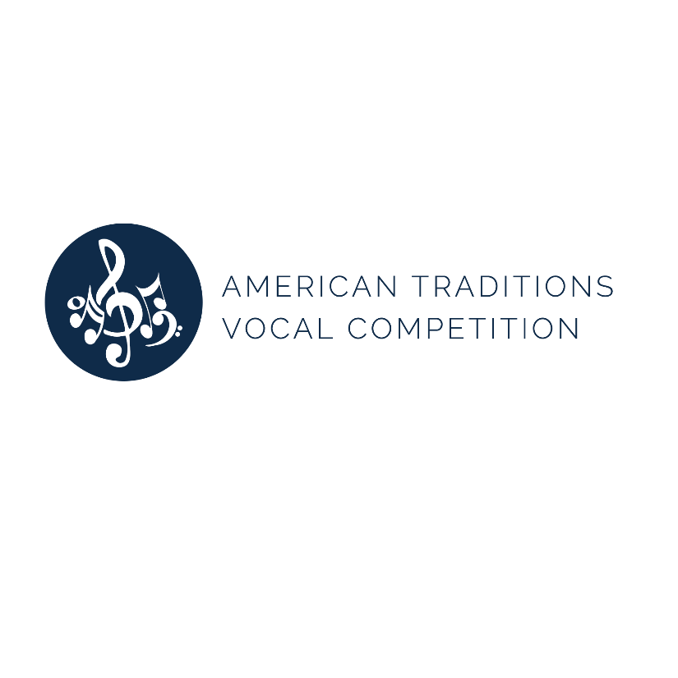

AMERICAN TRADITIONS VOCAL COMPETITION UNVEILS NEW LOOK AND WEBSITE AS NEW GENRES ARE INTRODUCED FOR APPLICANTS

SAVANNAH, GA – July 19, 2017 – The American Traditions Vocal Competition (ATC) has unveiled a new look including a brand new logo and contemporary website to coincide with the announcement of exciting new genres for the February 2018 competition, which will be the ATC’s 25th anniversary.
Applications open on August 1st for this silver anniversary of the ATC and, unlike most vocal competitions, there is no upper age limit for applicants although they do have to be at least 18 years old on the day the competition begins – February 19, 2018. Exciting new genres have been introduced for this year including pop/rock singer-songwriters 1980-today, popular music of 1950-1980, cabaret (not just modern) and a patriotic focus on the Great American Songbook with selections from the two world wars. Nine genres have to be selected by each applicant to demonstrate their versatility and the new genre options have been added to existing genres which include, opera, musical theatre, Hollywood, jazz, folk, country, art song, gospel, songs of Johnny Mercer, blues and religious music. In a bold move the ATC board has excluded a number of songs which have been over-performed in recent years including: “Moon River,” “Anyplace I Hang My Hat Is Home,” “Over The Rainbow,” “Maybe This Time,” “Gimme, Gimme,” “Blues In The Night,” “Summertime,” “His Eye Is On The Sparrow,” and “At Last.”
“I could not be more enthusiastic about our 25th year and I feel honored every day to be a part of this wonderful organization,” said ATC Artistic Director Mikki Sodergren. “This year will combine exciting updates with the very best of all that is traditional about the ATC and the beautiful ‘Hostess City’s’ rich history and vibrant cultural life.”
The ATC seeks to celebrate and preserve all styles of classic American music. The 501(c)(3) nonprofit organization promotes these songs by producing an annual vocal competition in Savannah, that awards over $35,000 in cash prizes. As part of community-driven service and initiative, the organization provides musical education, exposure and performances for Savannah locals of all ages.
Applications open for the 2018 competition on Tuesday, August 1 and close at 10 p.m. Friday, October 20. There is a $55 nonrefundable application fee. For more information on applying, instructions and rules, please visit www.americantraditionscompetition.com/application/.
To learn more about the ATC, please visit www.americantraditionscompetition.com.

- ENDS –
For media inquiries, please contact Hollie Barnidge at hollie@lesleyfrancispr.com or 912-272-8651 or Lesley Francis at lesley@francis.com at 912-429-3950 or the team at 912-417-LFPR (5377).

